GAME DESIGN DOCUMENT
Dont Be Rotten!!!
By Chris, Zubair & Leen

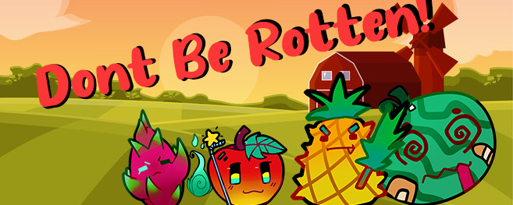

 | Revision | Table
Version | Changer | Date | Notes
1.0 | Chris | 27/03/2021 | First draft
1.1 | Chris | 30/03/2021 | Standardised font and formatting  Added Card Design Section
1.2 | Zubair | 31/03/2021 | Added Diagram for layout scheme  gaming aesthetics
1.3 | Chris | 22/04/2021 | Added & removed to fit Changes made mid development

TABLE OF CONTENTS

Game Analysis 4
Mission Statement 4
Genre 4
Platforms 4
Target Audience 4
Game Lore & Characters 5
Gameplay 7
Overview of Gameplay 7
Notable Features/Uniqueness 7
Player Experience 7
Game Objectives & Rewards 8
Gameplay Mechanics 8
Setup 9
One Minute of gameplay 9
Card Design 10
Layout Scheme 11
Game Aesthetics 13
Project Management 13

Game Analysis
Welcome to Don’t Be Rotten! Where all players will have fun helping their trusty fruits concur treacherous fields of the evil Veggies and make it to the all mighty fruit basket.
The purpose of this game is for players to go through the field and fight off the enemies in multiple levels and waves and to reach their end goal. Players will have to work together as proper teamwork and strategizing is vital to defeat the enemies.

Mission Statement
Don’t be rotten is a Card Dungeon Crawler tabletop game where players will have to work together to go through the fields, through multiple levels to reach the end. Players will have to fend off multiple enemy waves with different strength levels and variants in the field levels.

Genre
Don't be Rotten!!! is a tabletop dungeon crawler card game although in a much more simplified manner than most dungeon crawler games.

Platforms
This game is not going to be on any platforms in the initial stage as it will solely be a card game meant to be played in real life. Initial stages will not have a digital version on any platform except for PC which will have the game available on Tabletop Simulator.

Target Audience
This game is mostly targeted towards fans of the dungeon crawler/RPG genre, ones who enjoy a challenge and silly premise within games. People who enjoy games where there are different classes will be attracted to this game, and ones who enjoy randomly generated PVE will also find enjoyment. Some might dislike the heavy RNG elements of this game, but to many others it's appealing due to its potential. The game is accessible to audiences from all skill sets due to the simple nature of the game.
There is no specific age group for this game but looking at the style of the game determines that pre-teens and adults will be more likely to play this game. The market for this game is not over saturated, there might be many RPG games, but they are all individual that makes it not overly saturated. Scooter Campbell (2020) stated that he did not agree to the statement that RPG games are overly saturated. He believed that there are a lot of games but are meant for shorter play timing than in past games.

Game Lore & Characters
In a world where Vegetables reign supreme on the fields a small group of fruits must work together in order to reach the promised land from stories of old . . . The fruit basket. Our Heroes must fight through the hordes and reach the promised land in order to gain their freedom and be free of the vegetable’s tyranny on the fields.

Character | Description | Characteristics | Misc. Info
Watermelon  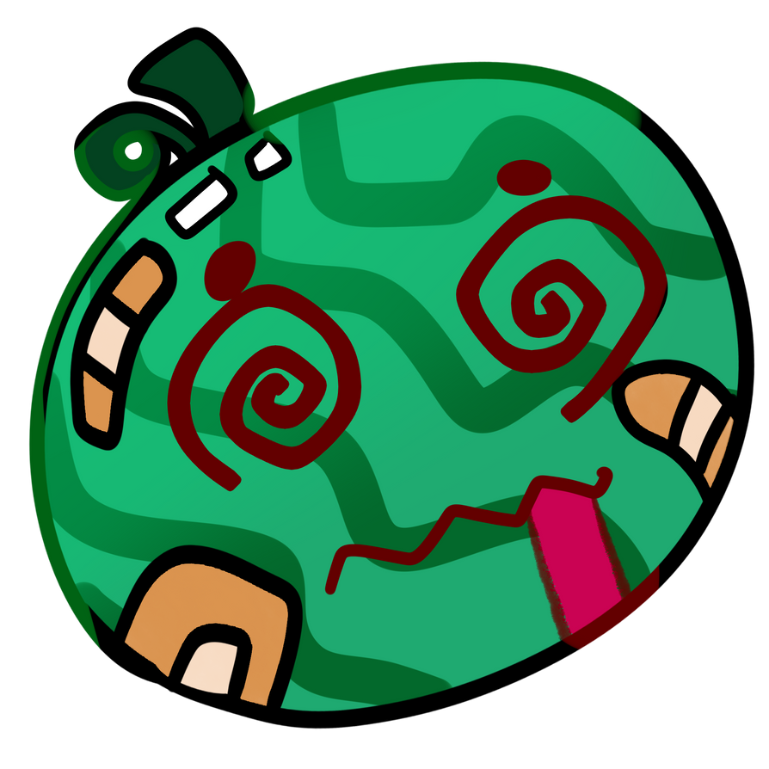 | Watermelon being the largest is also the best in the group when it comes to defense, usually always using his body to shield the rest of the group from enemy attacks | Large, Bulky and very tough. Very composed | High Health & low Attack
Apple  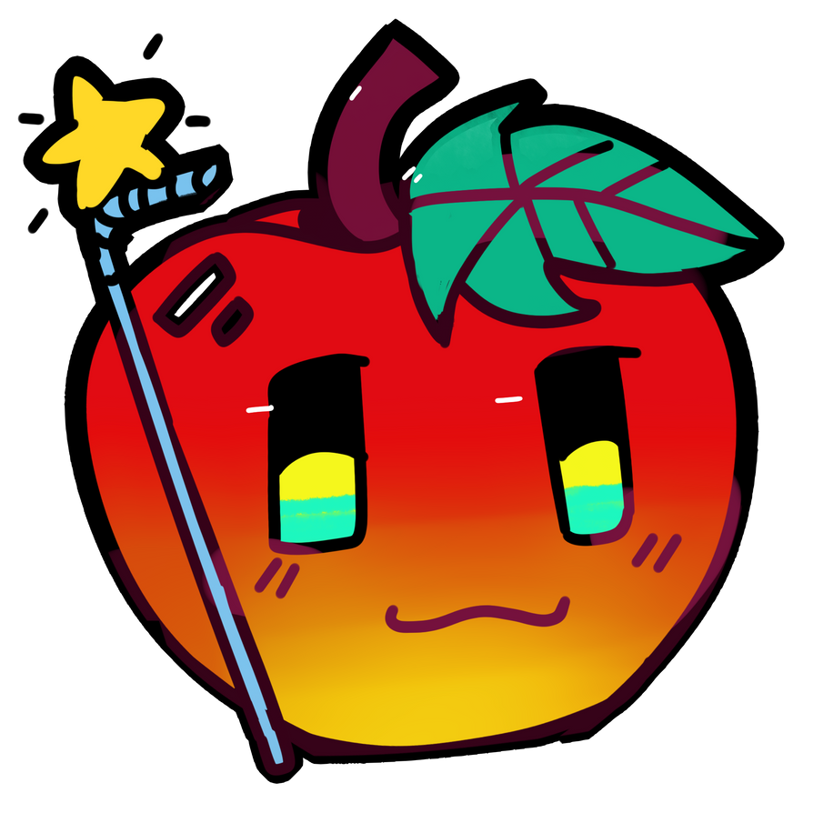 | The most refreshing of the group Apple is able to heal others with its aura removing their fatigue and healing injuries so that the fight can go on | Bright joyful and kind to their companions | High health & low Attack
Dragonfruit  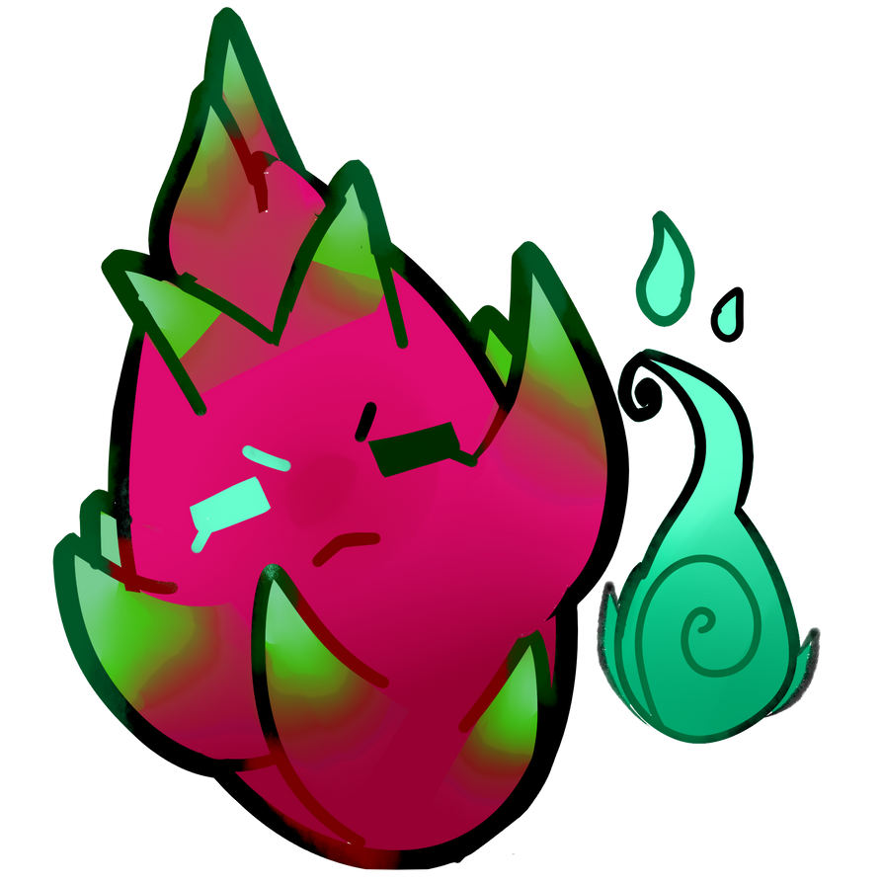 | The most mystical of the fruit, the Dragonfruit uses mysticism to combat enemies from a distance effectively preventing enemies from damaging it easy | Very Calculating, strategic in their movements and what they do. | Medium Health & medium Attack
Pineapple  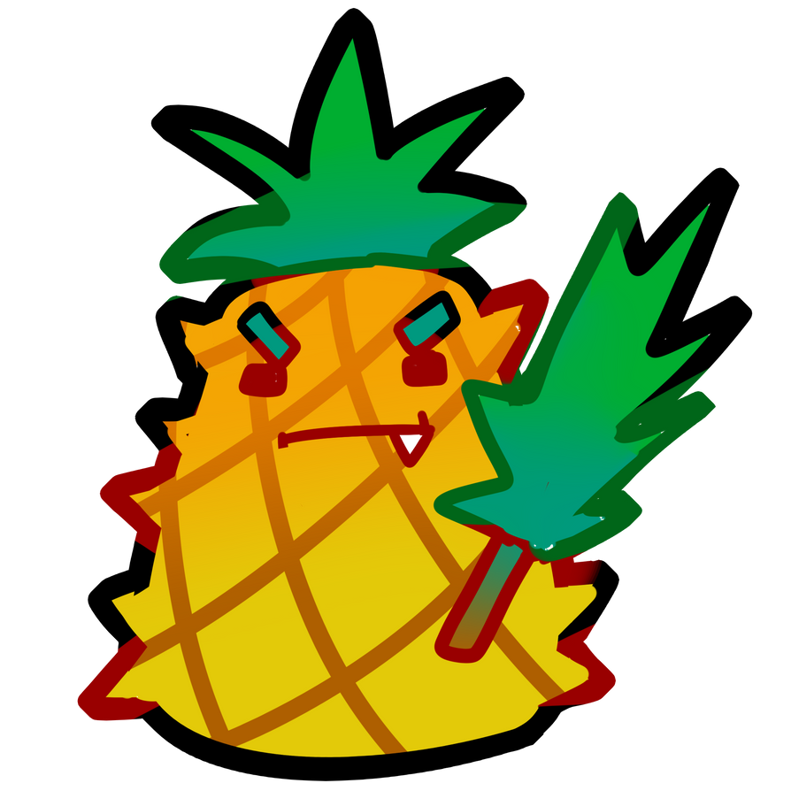 | Pineapple is very effective in close range combat, effectively a Knight they stand at the forefront to take down the enemies in their path | Chivalrous and very formal when interacting with others | Medium Health & high Attack
Lychee  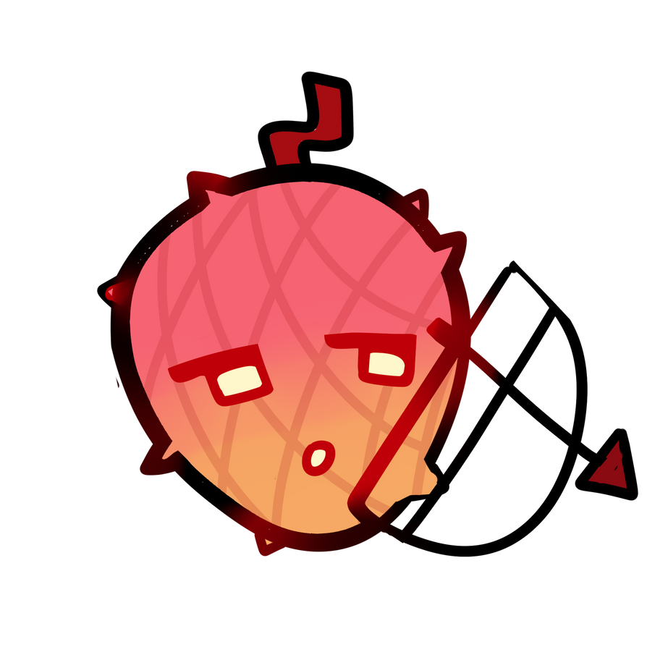 | One of the best when it comes to ranged combat Lychee is able to attack enemies without giving them a chance to retaliate. | Calm and introverted at heart, not very talkative with others | Medium Health & High Attack
Durian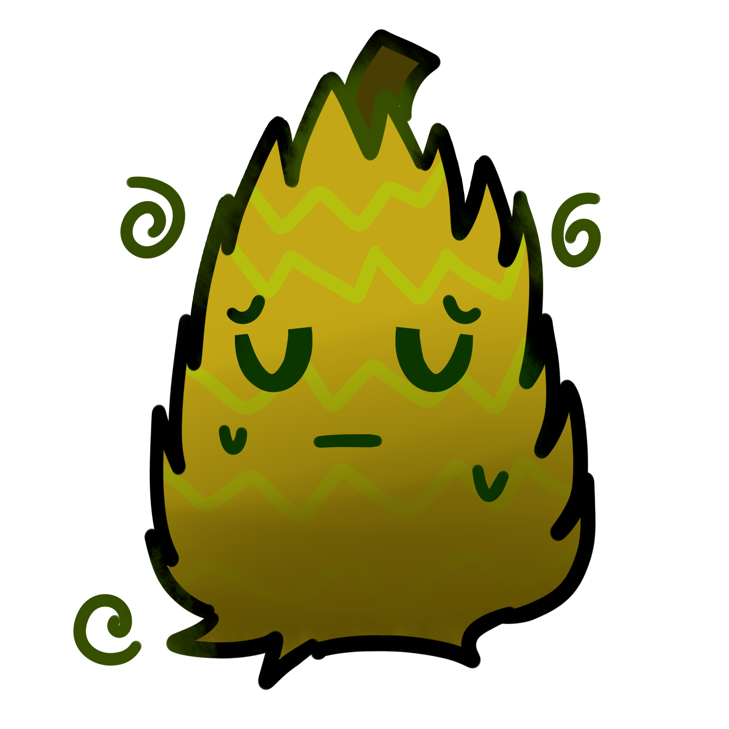 | After many experiments in the Lab Durian is very resilient however avoided due to its horrible stench as a result of constant chemical’s exposure | Very sporadic with their words though slightly isolated due to their smell | High Health & Attack

Gameplay

Overview of Gameplay
This game is most similar to a dungeon crawler, but has RPG elements. It is recommended to play this game with 4 players, but you may also play solo. This game offers a unique experience every time you start a new run, and each difficulty can have a range of toughness dependent on your luck. You may have an easier run on the hardest difficulty compared to last time for example, it is all up to RNG.

Notable Features/Uniqueness
A feature that makes this game stand out is how each run is completely decided by RNG, making every run it’s own unique and engaging experience. Players determine their stats by rolling, they roll in order to determine their character class and players also have to draw a field card to determine the overall way the run will play out. Not to mention that enemies are randomly drawn from a deck separated by difficulty so even if it's the same field they drew last time the enemies they’ll fight will be different. Our theme is also different as we have players being fruits fighting against vegetables.

Player Experience
When playing this game you will have the challenge of trying to clear a dungeon like any other dungeon crawler except for the fact that each run won't really be the same. For one the only thing you can determine for your character is their stats however even that is more up to your luck, not to mention that your class is determined by rolling as well. After that the difficulty of the dungeon will depend on what your group has drawn from the dungeon deck. You can see how many enemies you’ll have to face but you won't be able to tell what enemies they are until you draw and flip their cards over. You will experience the challenge of having to make do with your hand should it be an undesirable roll that you got when creating your character (Both class and Stat wise). Of course the challenge to you will be whether you will be able to clear this dungeon with the hand you’ve been dealt or will you suffer defeat instead.

Game Objectives & Rewards
Rewards | Penalties | Difficulty Levels
-Status boosts on every floor clear | -The rng within enemy generation  -The rng when you are rolling for the players, there are no role caps | You may choose between 3 difficulties, easy hard and medium, all of them dictates how difficult your enemies and waves will be

Gameplay Mechanics
Character Attributes
Character | Movement Abilities / Actions Available
Watermelon | Shields 2 members for 2 turns, may be used every 5 turns
Apple | Heals their team over the course of 3 turns slowly, may be used every 5 turns
Dragonfruit | Shield themselves for 2 Turns. May be used every 5 Turns
Pineapple | May go in front of their team regardless of team order for 1 turn, any attack during the turn will deal 1.5x damage, may be used every 5 turns
Lychee | Stun an enemy for 2 turns. may be used every 5 turns
Durian | Will poison the enemy for 3 turns. This may be used every 5 turns.
Items Cards
Item | Effect
Fruit Juice | Heals Player a certain amount
Garden Hoe | Hit all enemies for a certain amount for 3 turns
Garden Spade | Attack doesn't miss and increases Damage
Kitchen Knife | Take two turns instead of one
Tree Sap | Revive a Dead Player (Including themselves)
Veggie Juice | Lose half health for increase in attack for 3 turns
Veggie Wash | Stun up to 2 enemies for a turn
Game Modes
Easy / Medium / Hard | Enemy difficulty and number will increase accordingly.
Scoring System
Points/Coins/Stars/Grades/Etc. | How it’s Awarded & Benefits
Stat boosts | After every clear, each player is rewarded with a number of stat boosts to make them stronger.
Items | Players will receive 2 Items after every round

Setup
The game can have up to 4 players playing the game. Although not required it is recommended to have a Game Master to play for the enemies regardless of if they are one of the participating players. The game is played the same way solo as when it is played with multiple people the only difference will be that the player will have to roll for the enemies in a randomised manner if they want to maintain fairness in their run. The difficulty will also be much higher the less players there are

One Minute of gameplay
- After we’re done with the initial setup of the game (i.e stat allocation, class allocation, dungeon layout drawing and item drawing) the game begins
- Based on dungeon layout drawn at start of game we draw random enemy cards following what the layout card states
- After drawing and placing as stated by layout the enemy cards are then flipped and the battle begins.
- We will take turns in a clockwise direction and the first player can be determined by roll of the die.
- We will decide whether we want to use our class ability, an item or roll for an attack.
- If we choose to use our Class ability then we follow the instructions on the class card stating what the ability does and its cooldown.
- If we choose to use a Item card then we follow the items instructions and discard the item card.
- If we choose to attack then we choose an enemy to attack and roll two 8 sided dice. If the sum of the two die is even then we hit, if it is odd then we miss. If the sum is above 8 then we land a critical, increasing our damage a certain amount depending on our dice sum.
- If it hits then we deduct our attack stat from their health adding our critical if we have any.
- Once we’re all done with our turns the game master will run randomised turns for the enemies (randomly choosing players to attack or using their abilities) following the same steps that we took.

Card Design
The visual style of the game will be Cartoony. Using a cartoonish style will be more appealing to the eye. We wanted the game to be exciting and take the individual out of the realistic aspects of everyday life, which realistic games are more focused on. The art style we are going for in the cards is referenced by the classic game Plants VS Zombies.
There will be multiple decks in the game in order to build the scenario and determine the enemies players will face in each battle. When it comes to fields(dungeons) there will be 5 different layouts that players can draw each one being a different difficulty and changing the length of playtime as a result. There will be three decks for enemies (Different stages of difficulty) and each deck will have multiple cards of 5 different variants of enemies each. There will also be cards of player classes to show how to change their starting stats to fit with the class as well as their class ability.

Cards
Player Class Card  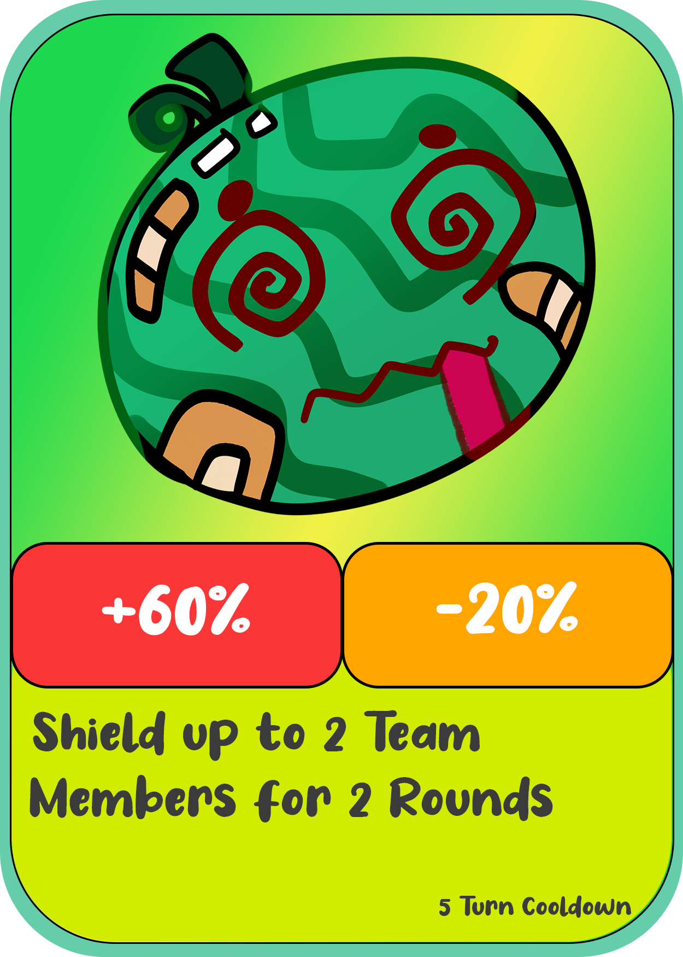 | This is the card players will use to gain information on the class of their character. The open area will be an image of the type of fruit that they are.  Where it says health, attack & defense is where it will let the player know how to manipulate their base stats that they rolled for. For instance the health could be multiplied by 2 and the defense would be halved. It would be shown here.  Lastly is the bottom of the card where it will give details on the ability of the class including what it does as well as its cooldown.
Enemy Card  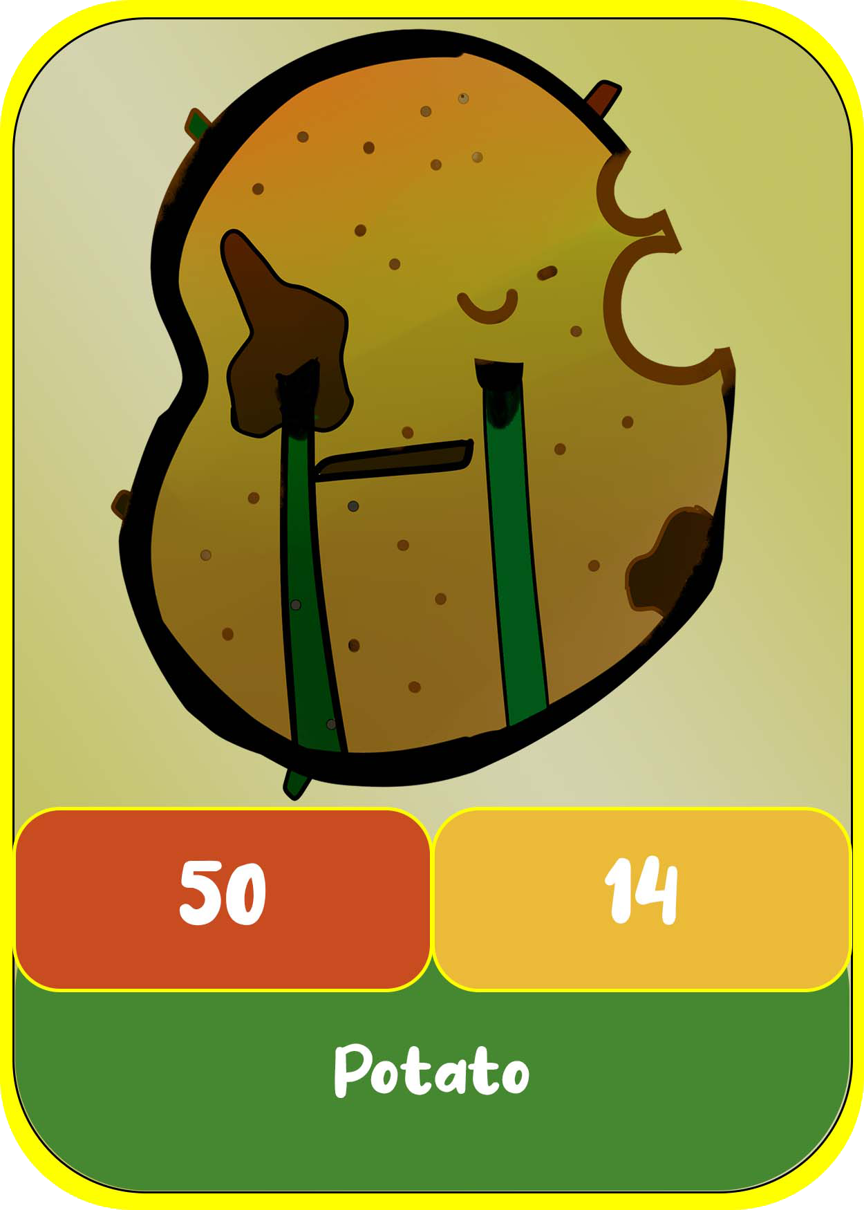 | This is the card used to display information of enemies with the open area showing how the enemy looks  Where it says health, attack & defense is where it display the stat values for the enemy  Lastly is the bottom of the card where it will give details on the ability of the enemy including what it does as well as its cooldown.  The outline will be a different color depending on the difficulty of the enemy (Yellow = Easy, Orange = Medium, Red = Hard)
Field Card  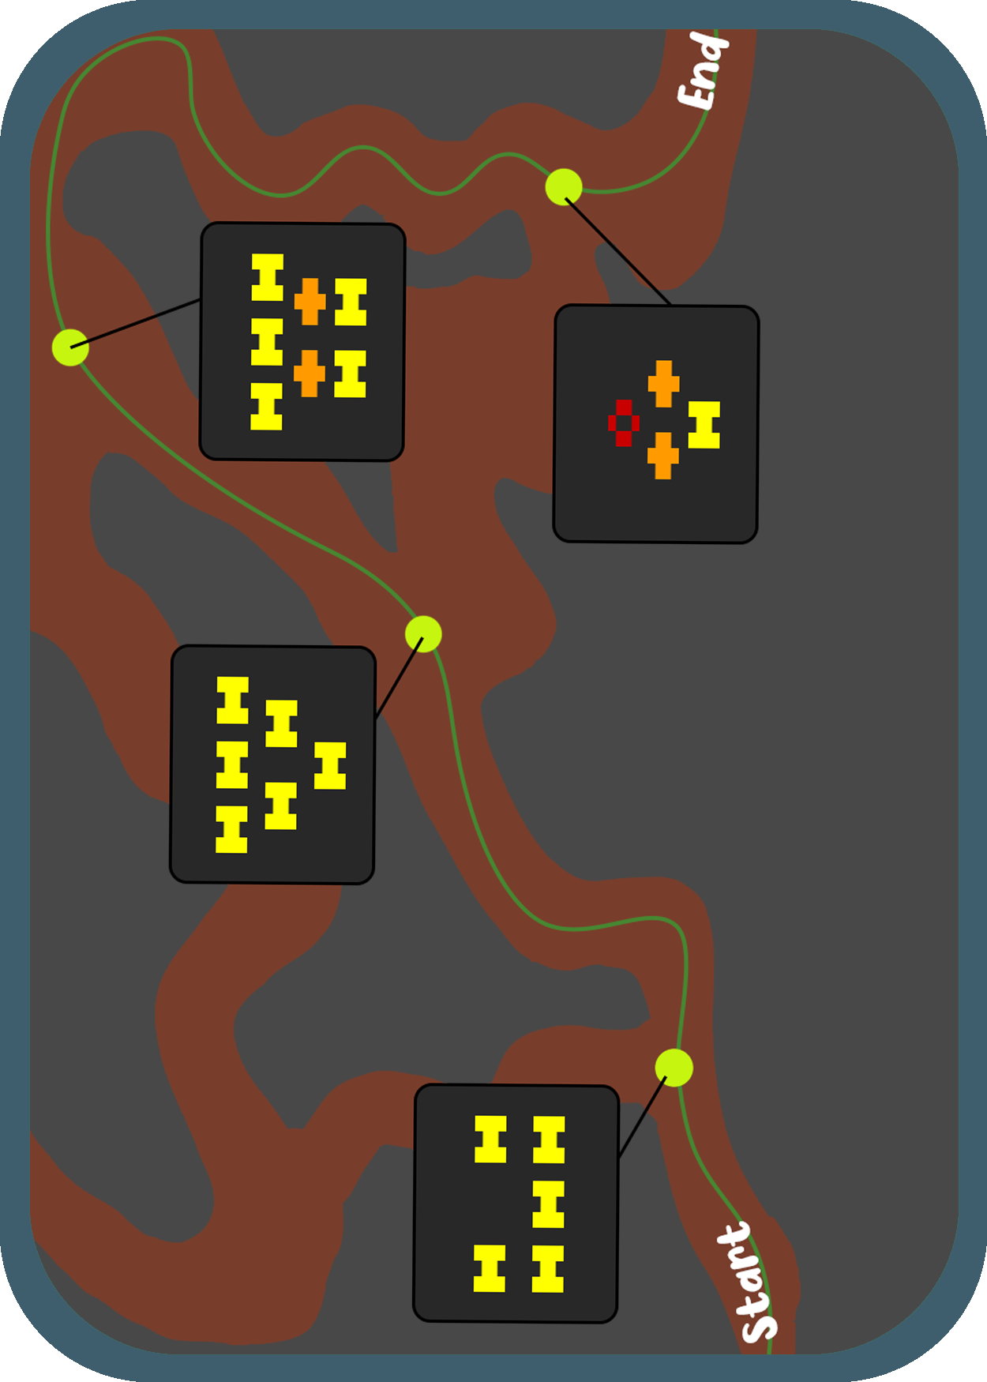 | This is the card used to display information of how the game will go.  It will show the ‘path’ players will take and the order of encounters  It shows how many and what category of the enemies at each encounter. It also shows the formation of the enemies (Bottom = frontmost, Top = Backmost)

Layout Scheme
The layout of the game goes as follows. There are 3 decks for the enemy cards with each corresponding difficulty, a field deck, 6 cards for the fruits, a coin, a 6-sided dice and a 20-sided dice. The field cards will be in a deck, it will be shuffled at the start and a card will be drawn from the deck and placed in the middle of the table so all players and game master can see how many levels and how many waves of enemies are in this specific field. The game master will also pick out cards for the enemies (veggies) and from the corresponding deck if need be. Players will roll the 6-sided dice to get their cards (fruits) and keep it in front of them and use the D20 dice to get their stats. The coin will only be used during combat to know if players or enemies will hit or miss.
Deck
3 difficulty decks | There will be 3 decks with different difficulty levels. When players are at a certain encounter, the game master will place enemy cards corresponding to the difficulty of the enemies on that level as shown on the field card.
Item Deck | Deck of the various items cards for the game. 2 are drawn at the begg=inning of the game and 2 are drawn after each encounter
Field card deck | One player will choose a field deck card and place it in the middle of the table so the game master and all the players can see the layout of the field, how many levels there are and how many enemy waves there are with their corresponding difficulties.
Fruit cards | Players will get their fruit cards by throwing the 6-sided dice. Players may end up with all the same fruit cards because of the number they throw.
Coin & Dice
4x 6-Sided dice, 2x 8-Sided dice and 1x 4-Sided dice. | The D6s are used to roll for stats as well as player class. The D8s are used to roll for hitting or miss and the D4 is used for enemies to decide what player to hit in their attack

Game Aesthetics
The look that inspired the characters for this game are Plants Vs Zombies. Plants Vs Zombies has the look and feel we are going for with regards to the pictures of our cards, bother fruits and vegetables. The Field Cards has a pathway and levels designed on the cards, as it was created for the aesthetic of the game. This will make the players feel as though they are moving through the field’s pathway during the quest.

Our goal and hope for this game is to attract all age genres by making the theme of the game is cartoonistic. It will impact the players by bringing them excitement and joy when playing the game. Since the game has this style and the rules are not difficult to understand, most players will not get afraid to play it, this will spark a positive feeling and drive them to play our game more and more.

The greatest effect to our game is imagination. Players will have to use their imagination when playing as this will transcend them into the game. As they will not necessarily be physically moving in the game, the players must imagine that they are fighting through the pathways through multiple enemies, giving them a sense of accomplishment when reaching the end goal.

Project Management
https://trello.com/invite/b/zL9f2wEa/7d5db933691e1b91c5b0bed5384fbae0/gad-171-project-2
