Midnight Craving
Game Design Document

Overview 4
Mission Statement 4
Notable Features / Uniqueness 4
Target Market 4
Game Requirements 4
One Minute Of Gameplay 4
Visual Aesthetic 5
Risks and Challenges 5
Genre 5
Platform 5
Game Lore 6
Universe 6
Main Character 6
Gameplay Overview 6
Player Experience 7
Mechanics 7
Setup 7
User Interface 7
Character Design 8
The Plant 8
Level Design 8
The House 8
Concept Blueprints 10
Items 13
The flashlight 13
Batteries 13
House key 13
Nail gun 13
Planks 13
Nails 14
Steel Bars 14
Welder 14
Research notes 14
Major Objectives and Rewards 14
Tasks 15
Puzzle Design 15
Safe puzzle 15
Fireplace puzzle 15
Tape puzzle 15
Puzzle 4 16
Puzzle 5 16
Scripted Events 16
Audio 17
SFX 17
Ambiance 17
Music 17
Project Management 17

Overview
Midnight Craving is a first person horror game. You are a self proclaimed scientist that has managed to create a serum that accelerates the growth of plants. The only issue is, it worked too well. Now your once cute Venus Flytrap towers you in height and sees you as its midnight snack. Go around the house gathering supplies in order to barricade everything lest the plant escape and wreak havoc out there.

Mission Statement
As a small team of 3, it is our goal to produce a fun, scary, and story-rich experience, utilizing our skills to the best of our ability. We would like our game to be about an hour long with fast progression and no down time. Throughout the project, we also aim to strengthen our game dev skills during the process.

Notable Features / Uniqueness
- Varied storytelling through character monolog and through the environment
- Roaming plant that attempts to capture the player while they run around the house
- Unnerving atmosphere and high tension while the player attempts to hide

Target Market
This game is mainly targeted towards Horror enthusiasts who enjoy playing horror games for the thrill of it as well as figuring out what the entire story is.

Game Requirements
OS: Windows 7 (64 bit) or Newer (64 bit) Windows OS
Processor: 2.5 GHz Dual core
Memory: 4 GB RAM
Graphics: NVIDIA GeForce 760, AMD Radeon R7 270X, or better
DirectX: Version 11
Storage: 1GB available space

One Minute Of Gameplay
- I awake in my room to the sound of something breaking in the house. My character gets out of bed and has internal monolog wondering what the cause to the noise was
- I gain control and am able to wander around the room. When near the door to the room I am prompted to open the door.
- Opening the door I go out to the hallway and find that things are lying on the floor in the hall.
- One of the room doors seem to have been broken off of its hinges
- Going into that room my character begins to worry about ‘it’ having escaped, at the end of the monolog a strange sounds can be heard
- Turning around I briefly see what looks like a giant plant vine moving across the floor and disappearing around the corner
- My character mentions having to find items in order to start barricading parts of the house but rather to keep something out he says its to keep something from getting out.
- Going around the house I look for items that could be used for barricading when I hear creaking and other noises getting closer
- Looking around i see prompts to hide under a bed or in a closet
- Doing so I see a glimpse of a plant monster now looking around the room.
- After a bit it disappears and I leave the hiding place
- After having found some items that have prompted me to collect them I find windows and other parts of the house that either tell me to use and item or that I don't have what I need
- Not paying attention to my surroundings I am met with a jumpscare as the plant had found me and got close enough to catch me.
- I have become the plants food for its midnight craving

Visual Aesthetic
- Medium-Low poly.
- Dark atmosphere.
- Stylized.
- Various lighting and particle effects.

Risks and Challenges
We have a separate document forRisk Management.

Genre
Story driven, horror, point-and-click adventure.

Platform
Windows OS, downloaded from itch.io.

Game Lore
Story / Script

Gameplay Overview
- The player's only weapon is a flashlight which he uses to stun the plant monster if they are being chased.
- The only enemy/threat in the game is the plant monster.
- The plant monster will patrol the house in search of the player throughout the game, and eat them if they are caught.
- The player will need to solve environmental puzzles to progress and ultimately complete the game.
- Items collected in the game will be held in an inventory until they are used.
- There will be hiding spots throughout the game to escape/avoid the monster.

Player Experience
Being a horror game, the player will have a somewhat unsettling experience throughout, while following a simple story by means of environmental and inner monologue storytelling. While being hunted by the plant monster, the player will need to solve puzzles of different complexities to progress the game, and will be rewarded for doing so. Being chased by the monster will also cause a sense of panic. By the end of the game, the player will get a good or a bad ending depending on if they completed enough tasks.

Mechanics
- The player can interact with certain objects around the house
  - Doors
  - Items
  - Puzzle Objects
- The player can use a flashlight to see better in the dark lighting of the house
- The Plant will roam the house in search of the player

Setup
This is a one player game, so there aren't any connectivity requirements. There will be a checkpoint system where the player will respawn if they are caught.

User Interface
For Midnight Craving, while playing the UI that the player is provided with will be mostly non-Intrusive. The battery of the flashlight will be on the flashlight itself and not on a hud while objects themselves will have a highlighted outline on them rather than text telling the player that they can interact with the object. Although the monolog of the player character will be provided with subtitles as we won't really be doing voice acting and even if we did people usually prefer to have subtitles in events that they struggle to hear what is being said. Along with this any items that the player holds (limit to be determined) will have an icon on the bottom left corner in order to signify that the player currently has that item on their person to help with seeing what they still require for their tasks.

Character Design
All models will be low-medium poly with a stylized aesthetic.

The Plant
Our main, and only enemy will be based off of the plant monster from ‘Little Shop of Horrors’. It will look like a venus fly trap with a large head, thornes, animated vines, and various effects.
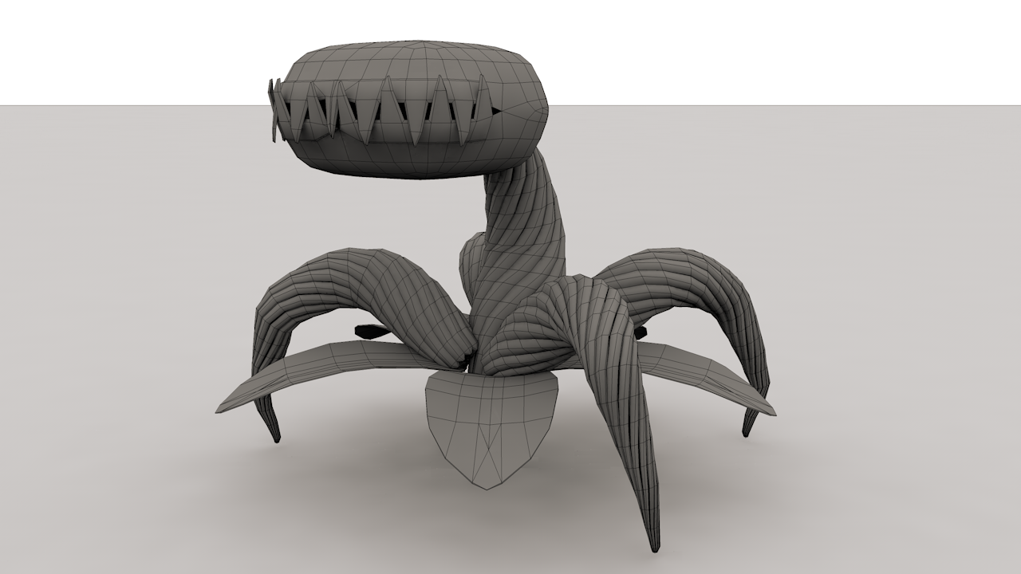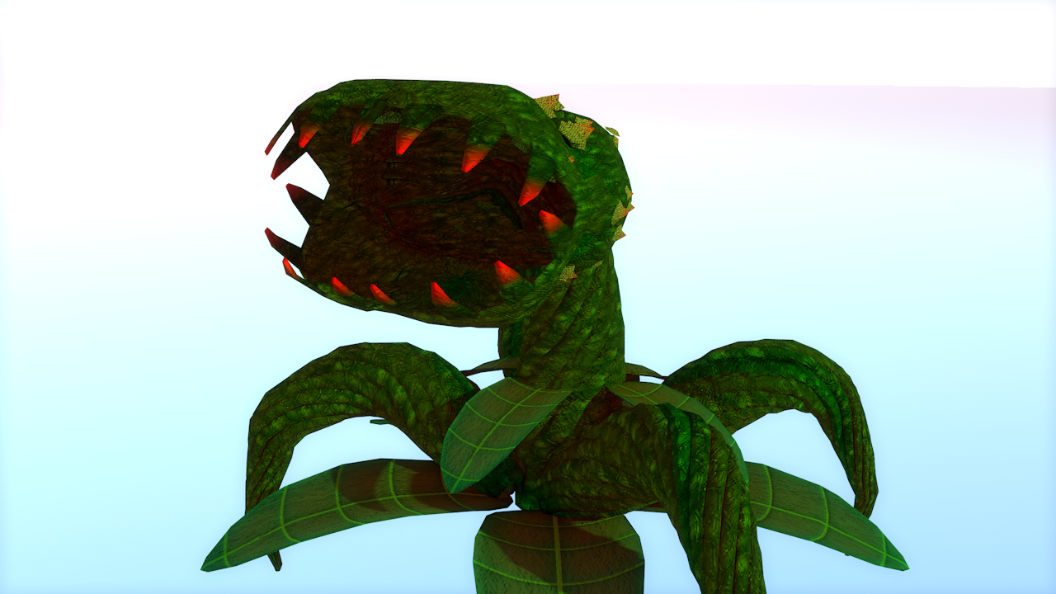

Plant Behavior
- Roaming Halls
  - Go through the halls of the house looking for player.
- Search Room
  - Select a room at random and enter looking for player
- Chase Player
  - If player in sight pursue player in order to capture them
- Stunned
  - Unable to ‘see’ or move for a short period of time
- Capture/Kill/Eat
  - Once close enough the plant will catch the player causing gameover

Level Design

The House
- The house will be a typical lived-in, medium sized building. Throughout the house will be diverse rooms and props that will tell the story of the game in a visual / environmental way. There will also be a laboratory inside where the main character has been doing his experiments.
- To show the age of the house, there may be things like broken pipes, flickering lights, stained carpets, weird paintings, and holes in the walls.
- There will be point-and-click style puzzles throughout the house for progression of the game, which will also tie into the story telling.
- The house will be visually dynamic throughout the game, becoming more and more decrepit as the monster seems to be taking it over.
- The style, shapes, and props may be sometimes peculiar to the player since the game is in a semi-unknown universe and history concerning technology is ambiguous.
- Due to the pathfinding of the AI of the plant, the house will be designed in a way where all of the rooms and hallways are somehow interconnected.
- There will be multiple hiding spots for the player to lose the monster if they are being chased.
- Rooms will be diverse, telling a different part of the story in each. Some rooms may be :
  - A laboratory
  - Kitchen
  - Bedroom
  - Bathroom
  - Garage
  - Storage
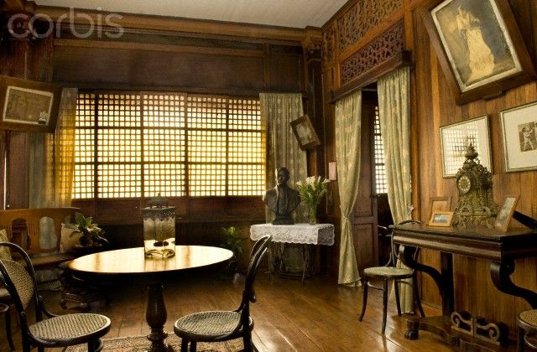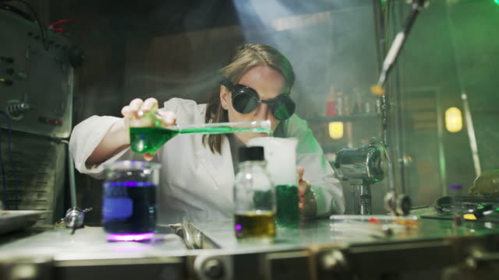
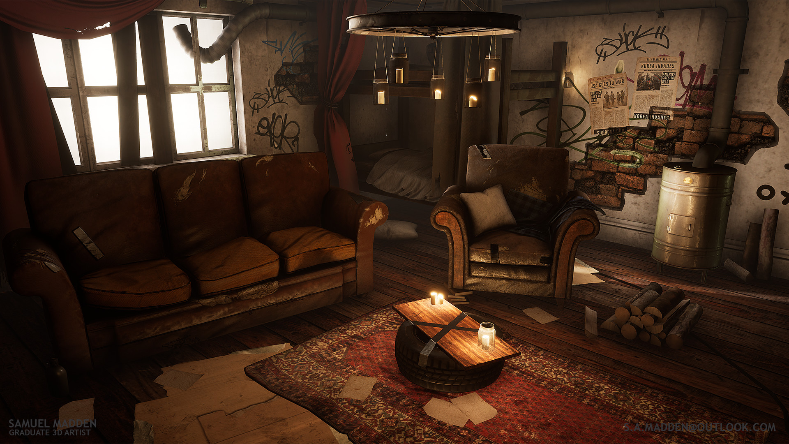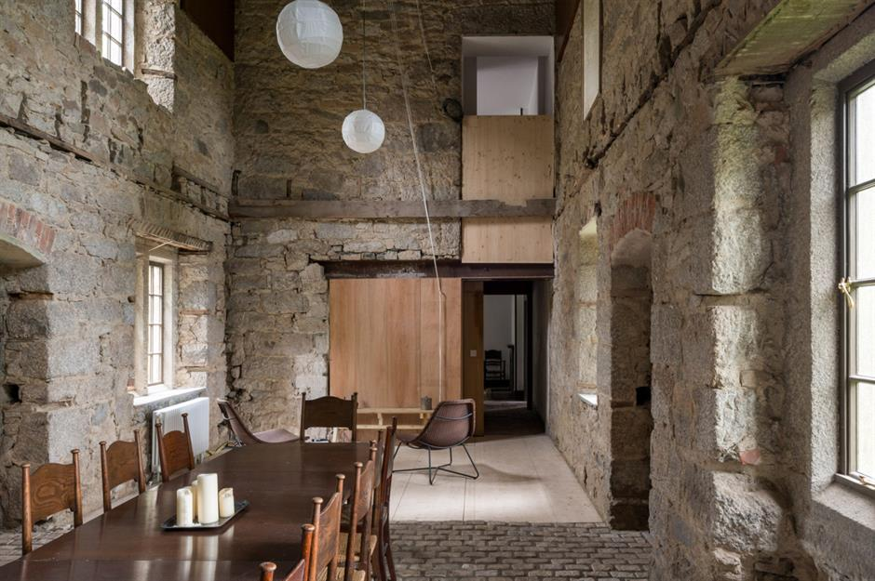

Concept Blueprints

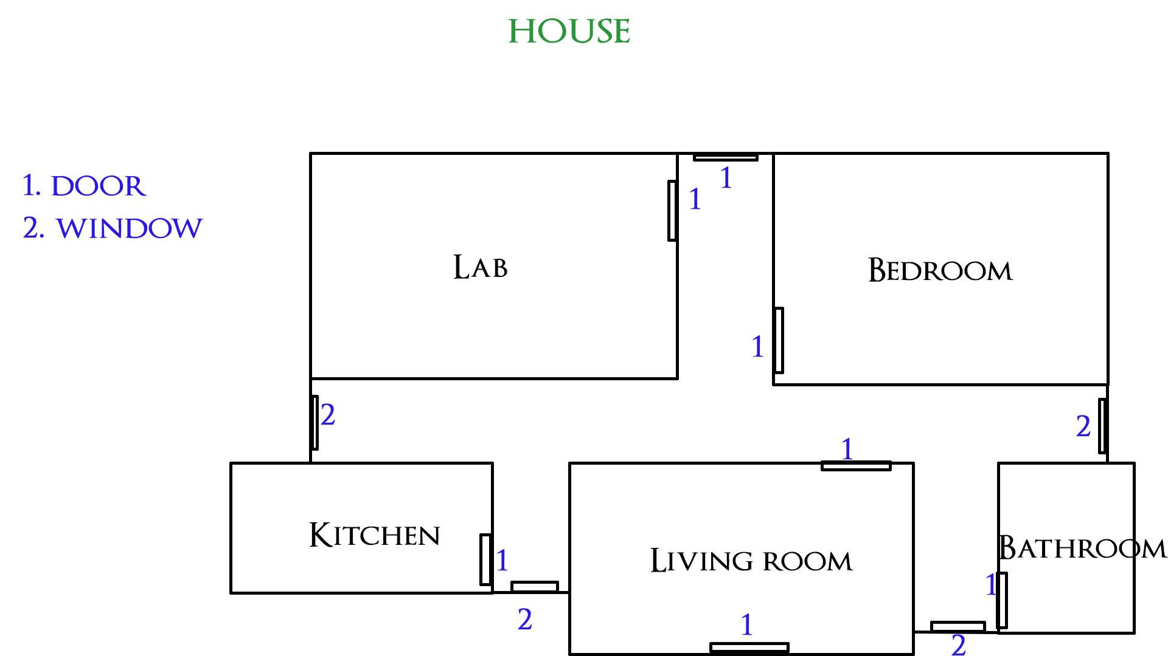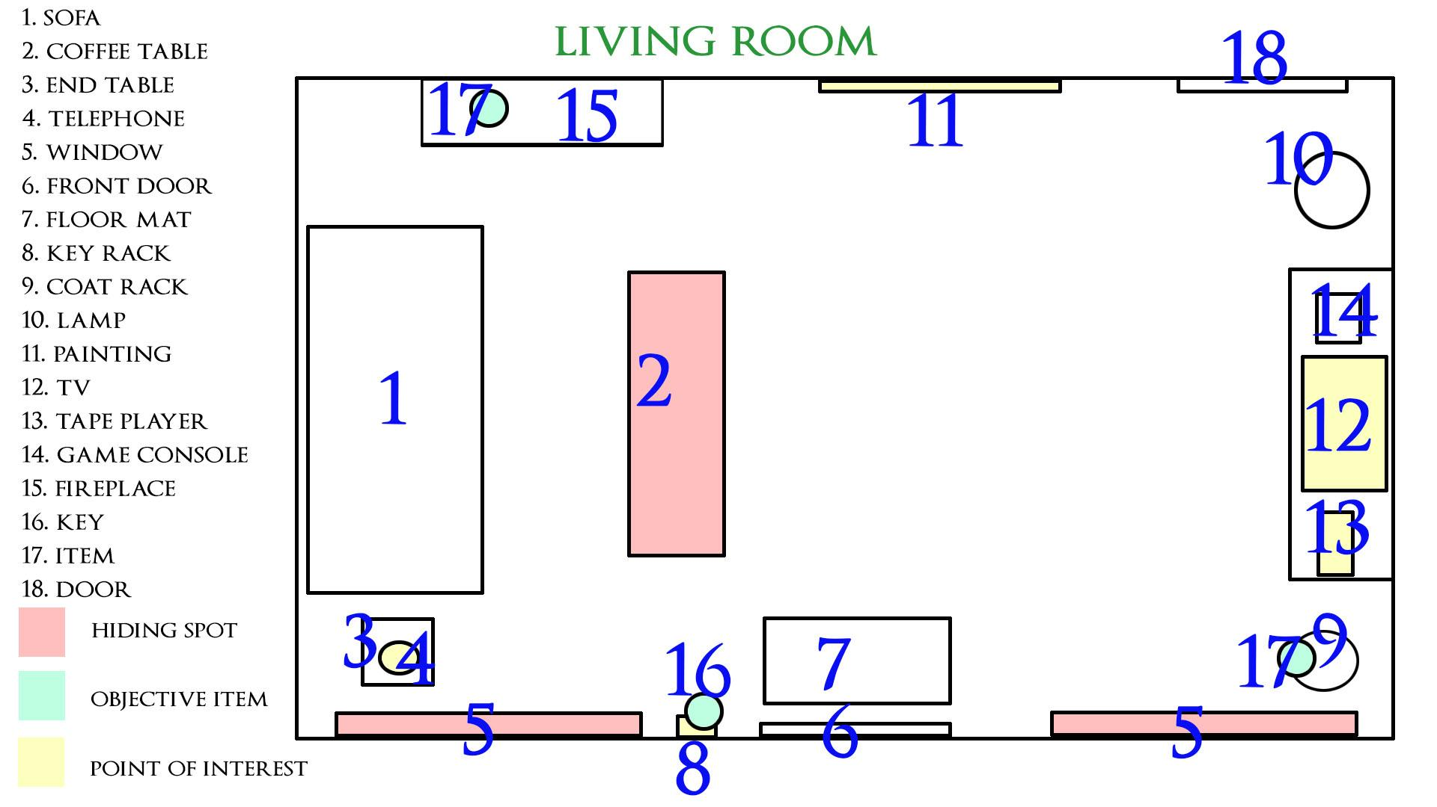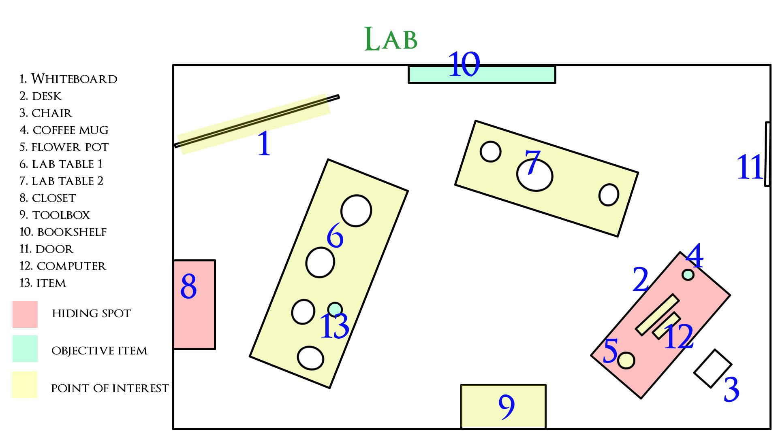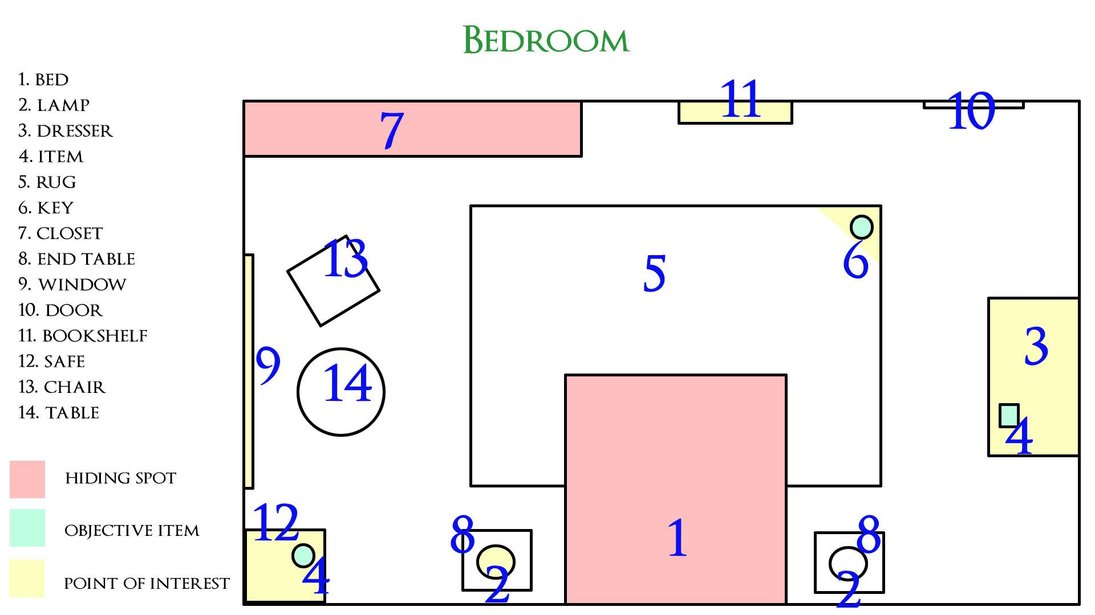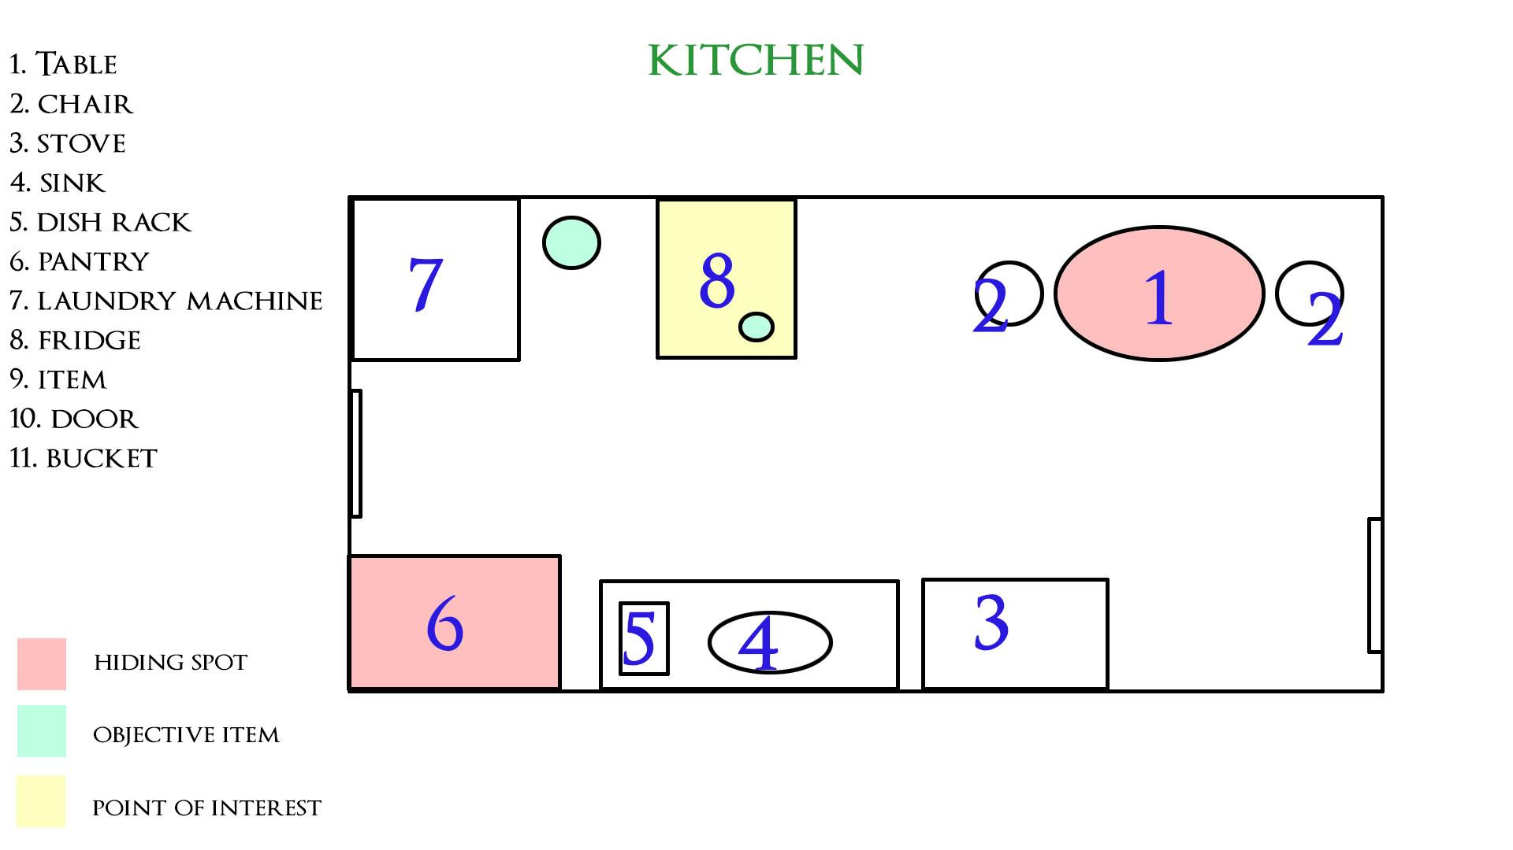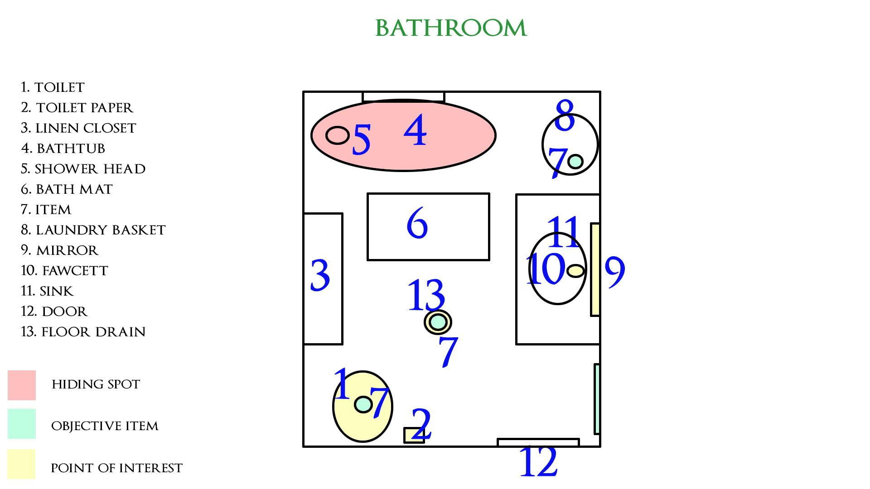

Items

The flashlight
- Picked up in the beginning room.
- The player's main weapon in the game.
- Used to blind / stun the plant monster.
- Has limited battery power
- Battery power can be leveled up by completing objectives.

Batteries
- Used to upgrade flashlight use time.
- Found in
  - Bathroom floor drain.
  - Pocket of coat on coat rack in the living room.
- Used to lock front & back door

Bucket
- Found after noticing the fireplace
- Used to put out the fireplace after filling with water

Drawer Key
- Found after completing the fireplace puzzle.
- Used to open the drawer of the lab desk

VHS Tape
- Found after opening the Desk Drawer
- Inserted into Tape Player in Living Room.
- Used to make the player aware of fogging the bathroom.

Hammer
- Found after completing the safe puzzle
- Used to nail the planks to the windows.

Planks
- Scattered throughout the house
- Just enough in the house to board up all the windows

Nails
- Scattered throughout the house
- Just enough in the house to board up all the windows

Jerry Can
- Found after doing all Barricades
- Used to fill rooms with gasoline.

Major Objectives and Rewards

Objective | Reward
Pick up flashlight in drawer | Obtain flashlight
Find video tape and play it in the tape player | Reveal method to obtain Safe Combination
Put out the Fire in Living Room | Obtain Drawer Key
Board up all windows (And backdoor) | Reveal task of pouring Gasoline
Pour Gasoline in all Rooms | Leave the house

Tasks
- Barricade Windows (Requires Nails, Planks & Hammer)
- Barricade Doors (Requires Nails, Planks & Hammer) Refers to backdoor, Character will automatically barricade front door if they have the required items
- Pour Gasoline in all Rooms (Requires Jerry Can)

Puzzle Design

Safe puzzle

Objective | Reward | Inner monologue
Turn on hot water in shower to fog up the bathroom, then look at the mirror. | Obtain the safe combo | “Clever Trick”
Open safe | Obtain the hammer | “I can board up the windows with this”

Fireplace puzzle

Objective | Reward | Inner monologue
Pickup bucket in lab | Obtain the bucket | “Lets fill this up shall we”
Fill bucket with water from kitchen sink | Obtain the water filled bucket | “Now to put out the fire”
Extinguish fire in fireplace | Obtain desk drawer key | “How did this end up here? I think this is they key for my desk drawer”

Tape puzzle

Objective | Reward | Inner monologue
Use fireplace key on lab desk drawer | Obtain video tape | “Didnt I put something important on this?”
Plug in TV to power outlet | Able to play the tape
Play tape in the tape player | Find objective to fog the bathroom

Computer puzzle

Objective | Reward | Inner monologue
Use computer password on lab computer | Get access to computer | “BINGO!”
Play mini game and beat it | Obtain a high score which is the code for…. | “I finally beat this stuipd game”

Scripted Events

Prerequisite | Location | Event
Walk out of the Lab | Main hallway | See a vine from the plant move across the floor around the corner
Leave the greenroom after investigating noise | Main hallway | Jump scare - plant chases you

Audio

SFX
- Footsteps
- Plant moving
- Plant groaning
- Plant attacking
- Plant stun
- Door open/close
- Flashlight
- Player death
- Fire extinguished
- Shower
- Fawcett running

Ambiance
- House ambiance
- Lab ambiance

Music
- Main menu
- Chase state
- Player death

Audio Events
- Heavy pounding
- Door creaking
- Bubbles groaning
- Glass breaking

Project Management

- Task Breakdown
- Meeting Minutes
- Hack n Plan
- Discord

